LAB SHEET 03

NAME-HARSHI JAIN , CU240250174 , Roll No. - 21

1. Set Up the React App Using Vite
npm create vite@latest react-todo -- --template react
cd react-todo npm install npm run dev
This creates a React application using Vite. The development server can normally be opened at the local address shown in the terminal.

2. Project Structure
react-todo/
├── src/
│ ├── components/
│ │ ├── AddTaskForm.jsx
│ │ ├── TaskList.jsx
│ │ └── TaskItem.jsx
│ ├── App.jsx
│ ├── App.css
│ └── main.jsx
├── index.html
└── package.json

3. Component Tree Diagram
App
│
├── AddTaskForm
│ └── input + Add button
│
└── TaskList
├── TaskItem
├── TaskItem
└── TaskItem

4. App.jsx — Parent Component
import { useEffect, useState } from "react"; import AddTaskForm from "./components/AddTaskForm"; import
TaskList from "./components/TaskList"; import
"./App.css";
function App() {
const [tasks, setTasks] = useState(() => { const
saved = localStorage.getItem("react-tasks"); return saved ? JSON.parse(saved) : [];
}); useEffect(() => {
localStorage.setItem("react-tasks", JSON.stringify(tasks));
}, [tasks]); const addTask = (text) => {
const newTask = {
id: Date.now(), text, completed: false
}; setTasks((prev) => [...prev, newTask]);
}; const toggleTask = (id) => { setTasks((prev) => prev.map((task) => task.id === id
? { ...task, completed: !task.completed }
: task
)
);
}; const deleteTask = (id) => { setTasks((prev) => prev.filter((task) => task.id !== id));
}; return (
<div className="app">
<div className="todo-card">
<h1>React Todo App</h1>
<p className="subtitle">Component-based task management</p>
<AddTaskForm onAddTask={addTask} />

<TaskList tasks={tasks} onToggle={toggleTask} onDelete={deleteTask}
/>
</div>
</div>
);
} export default
App;

5. AddTaskForm.jsx
import { useState } from "react"; function AddTaskForm({ onAddTask }) { const [text, setText] = useState(""); const [error, setError] = useState("");
const handleSubmit = (e) => {
e.preventDefault(); const value = text.trim(); if (!value) { setError("Please enter a task."); return;
} onAddTask(value); setText(""); setError("");
};
return (
<form onSubmit={handleSubmit} className="add-form">
<div className="input-row">
<input value={text} onChange={(e) => setText(e.target.value)} placeholder="Enter a task"
/>
<button type="submit">Add</button>
</div>

{error && <p className="error">{error}</p>}
</form>
);
} export default
AddTaskForm;

6. TaskList.jsx
import TaskItem from "./TaskItem"; function TaskList({ tasks, onToggle, onDelete }) { if (tasks.length === 0) { return <p className="empty">No tasks yet. Add your first task!</p>;
} return (
<div className="task-list">
{tasks.map((task) => (
<TaskItem key={task.id} task={task} onToggle={onToggle} onDelete={onDelete}
/>
))}
</div>
);
} export default
TaskList;

7. TaskItem.jsx
function TaskItem({ task, onToggle, onDelete }) { return (
<div className="task-item">
<label> <input type="checkbox" checked={task.completed} onChange={() => onToggle(task.id)}
/>
<span className={task.completed ? "completed" : ""}>
{task.text}
</span>
</label>

<button onClick={() => onDelete(task.id)}>
Delete
</button>
</div>
);
} export default TaskItem;

8. main.jsx
import { StrictMode } from "react"; import { createRoot } from "react-dom/client"; import App from "./App.jsx"; createRoot(document.getElementById("root")).render(
<StrictMode>
<App />
</StrictMode> );

9. App.css
* { box-sizing: border-box;
} body { margin: 0; fontfamily: Arial, sans-serif; background: #eef2f7;
}
.app { min-height: 100vh; display: grid; place-items: center; padding: 30px;
}
.todo-card { width: min(650px, 100%); background: white; padding: 30px; border-radius: 18px; box-shadow: 0 12px
35px rgba(0,0,0,.10);
} h1 { marginbottom: 5px; } .subtitle, .empty { color: #6b7280;
}
.input-row { display: flex; gap: 10px; margin: 25px 0
5px;
}
.input-row input { flex: 1; padding: 12px; border: 1px solid #d1d5db; border-radius: 8px;
} button { border: 0; border-radius:
8px; padding: 10px
16px; background:
#4f46e5; color: white; cursor: pointer;
}
.error { color: #dc2626;
}

.task-item { display: flex; justify-content: space-between; align-items: center; padding: 13px; margin-top: 10px; background: #f5f7fb; borderradius: 9px; }

.completed { text-decoration: line-through; color: #9ca3af;
}

.task-item button { background: #dc2626;
}

@media (max-width: 600px) {
.input-row { flex-direction: column;
}
}

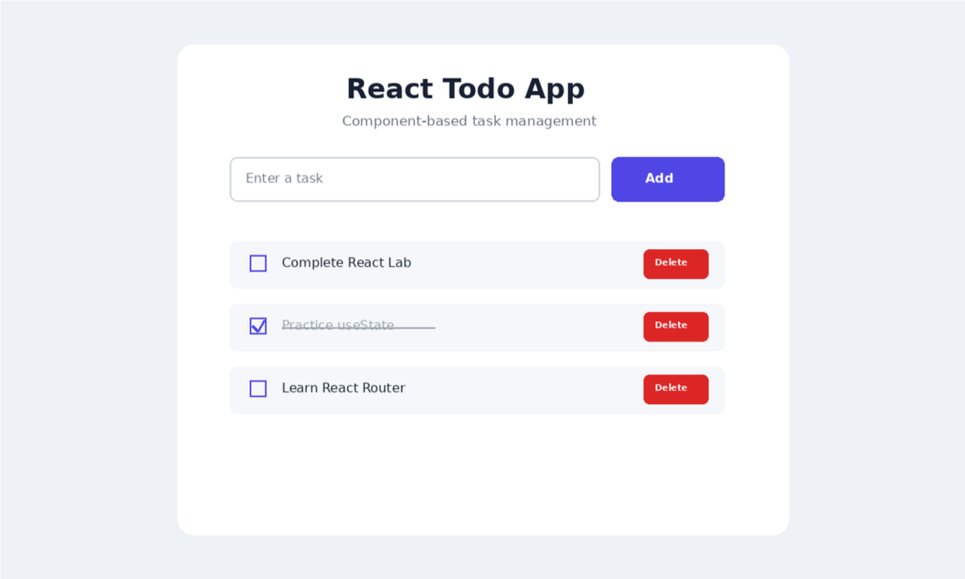

LAB SHEET 04
Name- Harshi jain, CU240250174, Roll N0. - 21
1. Install Dependencies
npm install react-router-dom

2. Project Structure
react-routing-app/ ├── src/
│ ├── components/
│ │ ├── Navbar.jsx
│ │ ├── ProductCard.jsx
│ │ └── Loading.jsx
│ ├── context/
│ │ └── CartContext.jsx
│ ├── pages/
│ │ ├── Home.jsx
│ │ ├── Products.jsx
│ │ ├── ProductDetails.jsx
│ │ └── NotFound.jsx
│ ├── App.jsx
│ ├── main.jsx
│ └── App.css
└── package.json

3. App.jsx — Routing
import { BrowserRouter, Routes, Route } from "react-router-dom"; import Navbar from "./components/Navbar"; import Home from "./pages/Home"; import Products from "./pages/Products"; import ProductDetails from "./pages/ProductDetails"; import NotFound from "./pages/NotFound";
function App() {
return ( <BrowserRouter>
<Navbar />

<Routes>
<Route path="/" element={<Home />} />
<Route path="/products" element={<Products />} />
<Route path="/products/:id" element={<ProductDetails />}
/>
<Route path="*" element={<NotFound />} />
</Routes>
</BrowserRouter>
); }
export default App;

4. Product Data
export const products = [
{ id: 1, name: "Wireless Headphones", price: 2499, category: "Electronics", description: "Comfortable wireless headphones with clear sound."
}, { id: 2, name: "Running Shoes", price: 1999, category: "Shoes", description: "Lightweight shoes designed for daily running."
}, { id: 3, name: "Smart Watch", price: 3499, category: "Accessories", description: "Smart watch with fitness and notification features."
} ];

5. Navbar.jsx
import { Link } from "react-router-dom"; function Navbar() {
return (
<nav className="navbar">
<h2>ShopReact</h2>

<div>
<Link to="/">Home</Link>
<Link to="/products">Products</Link>
</div>
</nav>
);
} export default Navbar;

6. Home.jsx
function Home() {
return (
<main className="page">
<h1>Welcome to ShopReact</h1>
<p>A simple React single-page shopping application.</p>
</main>
);
} export default Home;

7. Products.jsx — Product Listing
import { Link } from "react-router-dom"; import
{ products } from "../data"; function Products() {
return (
<main className="page">
<h1>Products</h1>

<div className="product-grid">
{products.map((product) => (
<article className="product-card" key={product.id}>
<h3>{product.name}</h3>
<p>{product.category}</p>
<strong>₹{product.price}</strong>

<Link to={`/products/${product.id}`}>
View Details
</Link>
</article>
))}
</div>
</main>
); } export default Products;

8. ProductDetails.jsx — Route Params
import { Link, useParams } from "react-router-dom"; import
{ products } from "../data"; function ProductDetails() { const { id } = useParams(); const product = products.find(
(item) => item.id === Number(id)
); if (!product) { return <h2>Product not found</h2>;
} return (
<main className="page">
<h1>{product.name}</h1>
<p>{product.description}</p>
<h2>₹{product.price}</h2>
<p>Category: {product.category}</p>

<Link to="/products">← Back to Products</Link>
</main>
);
} export default
ProductDetails;

9. CartContext.jsx — Global State
import { createContext, useContext, useState } from "react"; const CartContext = createContext(); export function CartProvider({ children }) { const [cart, setCart] = useState([]); const addToCart = (product) => { setCart((prev) => [...prev, product]);
}; const removeFromCart = (id) => { setCart((prev) => prev.filter((item) => item.id !== id));
}; return ( <CartContext.Provider value={{ cart, addToCart, removeFromCart }}
>
{children}
</CartContext.Provider>
);
} export function useCart()
{ return useContext(CartContext); }

10. main.jsx — Context Provider
import { StrictMode } from "react"; import { createRoot } from "react-dom/client"; import App from
"./App.jsx"; import { CartProvider } from
"./context/CartContext"; createRoot(document.getElementById("root")).render(
<StrictMode>
<CartProvider>
<App />
</CartProvider>
</StrictMode> );

11. ProductCard.jsx — Using Global State
import { useCart } from "../context/CartContext"; function ProductCard({ product }) { const { addToCart } = useCart(); return (
<article className="product-card">
<h3>{product.name}</h3>
<p>₹{product.price}</p>

<button onClick={() => addToCart(product)}>
Add to Cart
</button>
</article>
); } export default ProductCard;

12. Loading State
function Loading() { return ( <div className="loading">
<p>Loading products...</p>
</div>
);
} export default Loading;

13. NotFound.jsx — 404 Page
import { Link } from "react-router-dom"; function NotFound() { return (
<main className="page">
<h1>404</h1>
<h2>Page Not Found</h2>
<p>The page you requested does not exist.</p>
<Link to="/">Go Home</Link>
</main>
);
} export default
NotFound;

14. App.css
* { box-sizing: border-box;
} body { margin: 0; fontfamily: Arial, sans-serif; background: #f4f6f8; color: #172033;
}
.navbar { position: sticky; top: 0; z-index: 10; display: flex; justify-content: spacebetween; padding: 18px 7%; background: white; box-shadow: 0 2px 12px rgba(0,0,0,.08);
}
.navbar a { marginleft: 20px; color: #4f46e5; textdecoration: none;
}
.page { max-width: 1100px; margin: auto; padding: 50px
7%; }
.product-grid { display: grid; grid-template-columns: repeat(auto-fit, minmax(230px, 1fr)); gap: 20px;
}
.product-card { background: white; padding: 22px; border-radius: 14px; box-shadow: 0 6px 20px rgba(0,0,0,.08);
}

.product-card button, .product-card a { display: inline-block; margin-top: 15px; padding: 10px 14px; border: 0; borderradius: 8px; background: #4f46e5; color: white; text-decoration: none; }

15. Routing and State Flow
Browser URL
│
├── / ───────────────> Home
│
├── /products ───────> Products
│ │
│ └── /products/:id │ ↓
│ Product Details
│
└── any unknown URL ──> 404 Not Found

Global State:
CartProvider
↓
Navbar / ProductCard / other components
↓ cart + addToCart + removeFromCart

